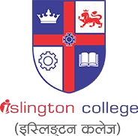

**Module Code & Module Title**

**CS6P05NI Final Year Project**

**Assessment Weightage & Type**

**5% FYP Proposal**

**Semester**

**2024 Autumn**

**PROJECT TITLE: SkillSwap**

**Student Name: Ashish Pradhan**

**London Met ID: 22068138**

**College ID: np01cp4a220484@islingtoncollege.edu.np**

**Internal Supervisor: Lekhnath Katuwal**

**External Supervisor: Pradeep Rimal**

**Assignment Due Date: 04th December 2024**

**Assignment Submission Date: 03rd December 2024**

**Word Count: 1853**

*I confirm that I understand my coursework needs to be submitted online via Google Classroom under the relevant module page before the deadline in order for my assignment to be accepted and marked. I am fully aware that late submissions will be treated as non-submission and a mark of zero will be awarded.*

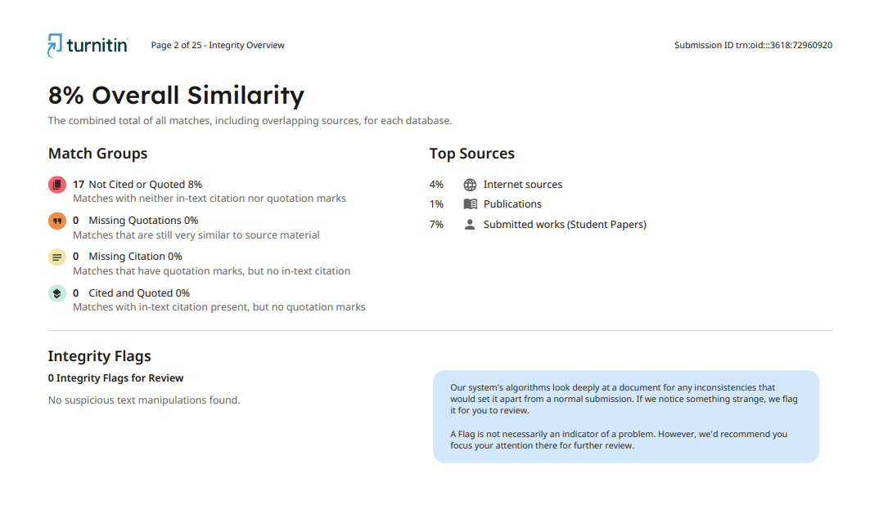

**Table of Contents**

1 Introduction 1

1.1 Introduction to the topic. 1

1.2 Problem Scenario 2

1.3 Solutions 3

2 Aims and Objectives 4

2.1 Aim 4

2.2 Objectives 4

3 Expected Outcomes and Deliverables 5

4 Project risks, threats and contingency plans 5

4.1 Project risks 5

4.2 Contingency plans 6

5 Methodologies 7

5.1 Considered Methodologies 7

5.2 Selected Methodology 7

6 Resource Requirement 9

6.1 Hardware Requirements 9

6.2 Software Requirements 9

7 Work Breakdown Structure 11

8 Milestones 12

9 Gantt Chart 13

10 Conclusion 14

11 Bibliography 15

12 APPENDIX 16

12.1 APPENDIX 1.1 16

12.2 APPENDIX 1.2 16

12.3 APPENDIX 1.3 17

12.4 APPENDIX 1.4 17

**Table of Figures**

Figure 1 : Online Learning Growth (Singg, 2024) 1

Figure 2 : Nepal GPD per capita. 2

Figure 3 : Global Weatlh and Income (WIR, 2022) 2

Figure 4 : Diagram of Agile Methodology. 7

Figure 5 : Scrum Framework Workings. 8

Figure 6 : Work Breakdown Structure for SkillSwap 11

Figure 7 : Project Milestone : SkillSwap 12

Figure 8 : Project Gantt Chart : SkillSwap 13

**Table of Tables**

Table 1 : Table for Considered Methodology 7

Table 2 : Table for Hardware Requirements. 9

Table 3 : Table for software requirements. 10

**AKNOWLEDGEMENT**

I would like to thank my Internal and External supervisor for their support, guidance, and constructive feedback that they have provided me for the project and the proposal till now. I am grateful towards Islington College for providing me with this opportunity due to which I gained valuable insights and experience. Finally, I want to express my appreciation towards my family and friends for their support and motivation.

**ABSTRACT**

This document focuses on the development of an online-learning platform SkillSwap, which facilitates the exchange of skills through course creation, sharing and enrollment supported by virtual reward system. The system will be built using MERN stack and relation database, emphasizing on scalability and efficiency. This platform aims to provide affordable and accessible skill-sharing solutions . By the end, SkillSwap will serve as a functional prototype displaying its potential to upskill personally and professionally.

**ABBREVIATION TABLE**

|  |  |
| --- | --- |
| **Short form** | **Full form** |
| MOOCS | Massive Open Online Courses |
| ARPU | Average Revenue Per User |
| DSDM | Dynamic System Development Method. |
| JWT | JSON Web Token |
| GNI | Gross National Income |
| UX | User Experience |

# Introduction

## 1.1 Introduction to the topic.

Learning new skills has always been an essential factor for developing personal and professional lifestyle. With the rise of technology, the arrival of online learning platforms has revolutionized how individuals gain knowledge, opportunities, and upskill by leveraging the features provided by such medium. (Ed-admin, 2023)

The post-pandemic era saw a surge in use of those platforms due to their practicality and digital education solutions. MOOCs platforms like Coursera, Shillshare, Edx etc. have created a market that is projected to reach almost $848.1bn USD (Kharrati, 2022)and host 1.0bn user by 2029, generating ARPU amounting to $75 USD (Statista, 2023). North America and Europe have seen sustained growth in this stage, while the Asia-Pacific region leads in adoption rates due to its expanding technology.

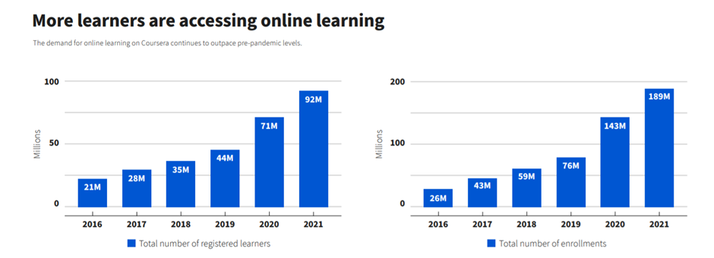

Figure 1 : Online Learning Growth (Singg, 2024)

Community driven platforms have not only help user explore new fields but also helped professionals increase their job opportunities and career advancements due to diverse offerings of online platforms. (Dr. (CA) Megha Sharma, 2023). Despite these advancements, most online platforms are heavily relied upon monetary transactions, creating barriers for those who cannot afford even the basic courses.

To address this gap, I propose developing a platform that replaces monetary barriers with community-driven learning, where users exchange skills instead of money.

## 1.2 Problem Scenario

Even though various online learning platforms have changed the way people learn and grow their skill, their high enrollment fees often make them inaccessible to those with limited financial means. For instance, courses on this platform range from $50 to $300 , which is huge amount for people living in developing regions. With $75 ASPU , they cater to people with high level income , leaving behind middle- and low-income learner unable to access this facility.

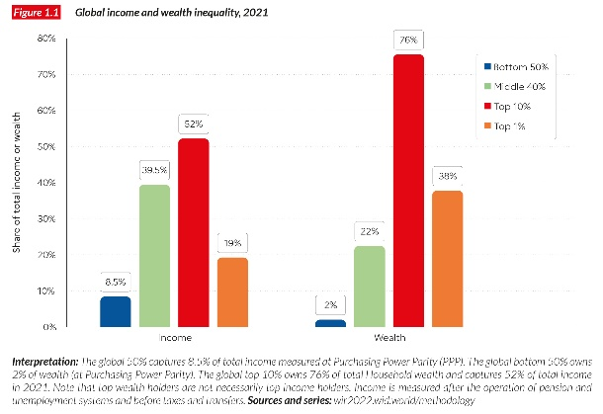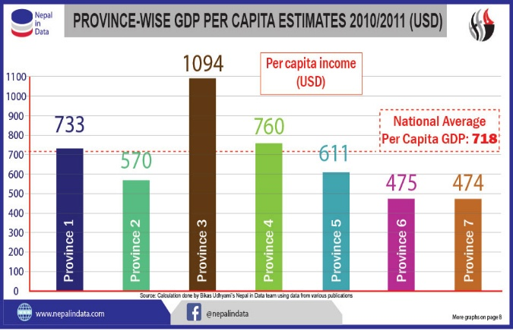In Nepal’s context ,the GNI per capita is approximately $1390 , therefore spending a mass portion of their income would not be viable or a sustainable option. This challenge is not common in Nepal (CEIC, 2023). Many different countries especially the developing ones having similar economic profiles, face skills gaps due to limited access to affordable resources.

Figure 2 : Nepal GPD per capita.

Figure 3 : Global Weatlh and Income (WIR, 2022)

Globally, over 2 billion people have to live less than $10 dollar a day, therefore making them spend it on basis survival needs. Therefore, this has created inequality in skill development and made it difficult for people to get jobs in today’s competitive market. Addressing this issue, a platform needs to be developed for erasing this financial barrier and provide well-deserved opportunities.

## 1.3 Solutions

**SkillSwap** , a community driven learning platform can help overcome the challenges mentioned above and transform the way skills are learnt. Developing a system of mutual skill exchange, Skillswap emphasizes an innovative approach by making courses available to all and eliminate financial barriers to learning.

The following are the features supported by SkillSwap : (for more detailed feature with benefits refer to APPENDIX 1.4)

1. Robust and Engaging Skill Coin System
2. Content Creation Opportunity and Rewards
3. System for Community Collaboration and Flexible Learning
4. Diverse Learning Areas

# Aims and Objectives

## Aim

The primary aim of this project is to develop an online learning platform that implements a robust reward-based system for facilitating learning activities, thereby helping every individual to equally acquire new skills by eliminating any financial barriers.

## Objectives

* Develop a web application having various online learning feature using MERN stack,
* Implement a secure and reliable profile management system with Login and Register for all the users using JWT for secure login and Bcrypt for password hashing.
* Develop a dynamic search feature for effective querying , finding courses and lessons.
* Develop a proper SkillCoin system to incentivize learning and posting. Real time update on user’s SkillCoin balance.
* Create Interactive spaces such as feedback, course review, ratings, and notifications.
* Develop a proper teaching features to enable content creators to post, edit and manage course through Content Management System built with React.js and Node.js with approvals managed by admins.
* Facilitate a secure marketplace for users to buy SkillCoins with payment integration and safe monetary transactions features.
* Develop a proper Admin Dashboard for monitoring overall application and user activity, content management and system performance.

# Expected Outcomes and Deliverables

After the completion of this project, it is anticipated that this community driven web application will allow people to learn and share skills seamlessly. It will help build an environment where creators and learners can engage in skill exchange with reward system called SkillCoin. The platform aims to break the financial barriers to learning and will provides tools for user engagement integrating comprehensive structure. Additionally, the application will integrate features such as personal recommendations and general asset management along with user-friendly interface with best learning experience. This system aims to bring development, collaboration and innovation in-between the people or its user base.

After explicitly defining the outcomes that needs to be achieved, the following represents a brief overview of the deliverables expected from the project :

1. **Fully Functional Platform**
2. **Documentations**
3. **A Final Deployment of the application**.

Full description of all the deliverables can be found on Appendix 1.3

# Project risks, threats and contingency plans

## Project risks

* Scope Expansion and Delays : Incremental and unplanned features additions along with poor time management may cause delay and pressure.
* API dependency and Server Downtime: Relying on API’s integrations such as for payments and account verification may poses risk if they face downtime. Underdeveloped infrastructure can lead to system failures.
* Data Security Breach : Low security authentication, data encryption and authorization features could expose the system to security breaches.
* Scalability Issue : Inadequate database and infrastructure could lead to performance issues as the user base in grows.
* Collaboration and UX issues : Due to poor communication and vague vision among the team could lead to design flaws and demote user experience.

## Contingency plans

Contingency plans act as a barrier to safeguard projects objectives and ensure smooth execution. (Admin, 2023)The following are the contingency plans for the projects:

* Use of Agile methodology with regular sprints can ensure timely deliveries of all the additional features.
* Scheduled security checks and strong encryption of sensitive data.
* Conduct timely testing of the system, meeting both functional and security requirements.
* Develop a system backup for server failure and retain system’s integrity.
* Reduce single point failures by integrating failure mechanisms and cache data to maintain operations during API downtime.
* Keep regular meetings among and user-testing to align with systems objective and enhance user experience.

# Methodologies

## Considered Methodologies

While choosing an appropriate development procedure for the project, many different methodologies such as kanban, DSDM were considered and explored thoroughly.

|  |  |
| --- | --- |
| **Considered Methodology** | **Reason for not Selecting** |
| **Kanban** | Not suitable for Skillswap, as it is a complex project needing time-boxed sprints and cycles for iterative development. |
| **Waterfall** | Too rigid and concise for improvement and scalability needed in skill swap |
| **DSDM** | Has more procedure rather than adaptation which is not suitable for complex project like SkillSwap. |

Table 1 : Table for Considered Methodology

## Selected Methodology

After the exploration, Agile Methodology was best fit for the project’s development. More about the selected methodology continues on APPENDIX 1.2

Figure 4 : Diagram of Agile Methodology.

Agile Methodology consist of multiple frameworks, one of them being Scrum. We will be implementing the same for SkillSwap.

**SCRUM :**

Scrum Framework will be the best suitable solution for SkillSwap platform as :

* Its iterative development will help developed and test features such as Reward system, course creation, enrolment etc. incrementally by identifying and resolving issues at the same time.
* The flexibility of scrum will allow the project to breathe and evolve , making it easier to implement changes based in the goals in the development process.
* It promotes regular discussion which ensures smooth operation and help resolve problems quickly.
* Features sprint, which are small iterative cycles through which functional features are delivered on time . It will also help mitigate risk by testing components in each sprint for the SkillSwap application.

Scrum Continued on 12.1 Appendix

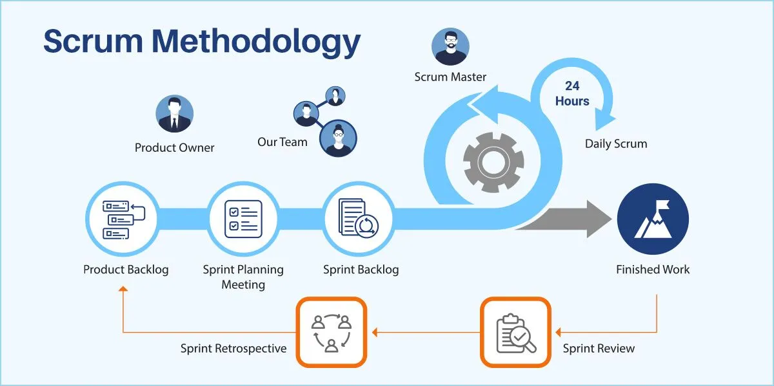

Figure 5 : Scrum Framework Workings.

# Resource Requirement

The basis hardware and software requirement to accomplish this project are as follows:

## Hardware Requirements

|  |  |
| --- | --- |
| **Hardware** | **Specifications** |
| Laptop  (Development Environment) | Processor up to Intel Core i5 or AMD Ryzen 5 , RAM 8GB or more, Storage SSD 256GB minimum, Graphics card recommended , OS windows 10/11 or Linux or MacOS. |
| Network | High speed and stable internet connection for dependencies, API and R&D. |

Table 2 : Table for Hardware Requirements.

## Software Requirements

|  |  |
| --- | --- |
| **Software Requirements** | **Software Specifications** |
| **Project Management Tools** | Trello for task tracking progress, TeamGantt for timeline visualization, Figma (v1.103.0) for Frontend and application designing (UI/UX) |
| **Documentation** | Tools such as Microsoft Word, Notepad to construct document and quick notes. |
| **IDE** | VS-code (v1.95.3) (with extension for JS, MongoDB , HTML/CSS etc) |
| **Database** | MongoDB supporting NoSQL . |
| **API Testing** | Postman for testing API related request and response. ( v11.21.0) |
| **Frontend Frameworks and Libraries** | HTML5, CSS, Javascript, React.js . Bootstrap., React Router(v7.0.1), Axios (v1.7.3) . |
| **Backend Framworks** | Node.js (v20.15.1), Express.js v03.2, JSON tokens , brcypt for backend development. |
| **Streaming** | ML based recommendation system such as TensorFlow.js or PyTorch. |
| **Media Tools** | Ffpeg for video procession or could fare and Vimeo/Youtube for media hosting integration. |
| **Deployment** | AWS service for hosting, S3 bucket for storage media and Load Balancer for traffic management. |
| **Version Control** | Git for version control and Github for storing backups, repository and collaboration. (v2.41.0.windows.1) |

Table 3 : Table for software requirements.

# Work Breakdown Structure

Figure 6 : Work Breakdown Structure for SkillSwap

# Milestones

The following milestone represents each of the essential step or phases in the development process of Project SkillSwap, with clear understanding and division of work in a timely manner. It will be very easy for the development team to get the objectives done within the set deadlines.

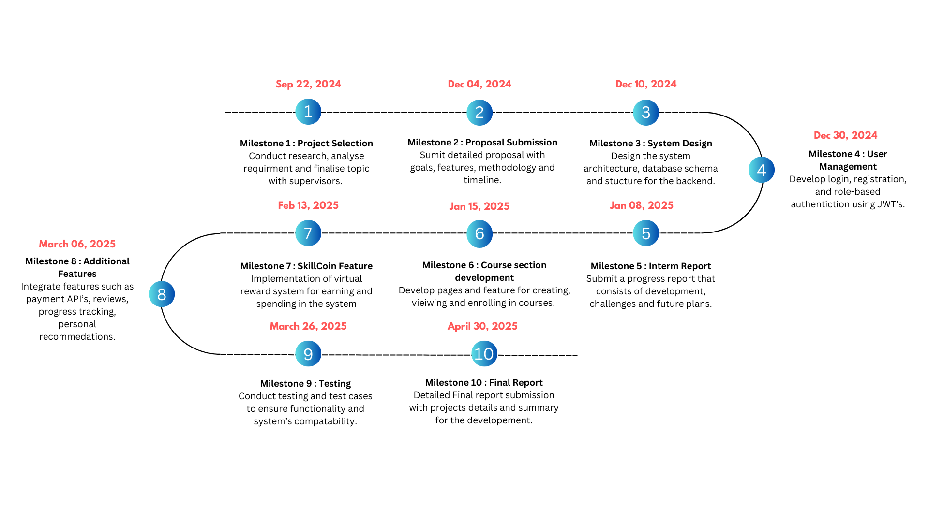

Figure 7 : Project Milestone : SkillSwap

# Gantt Chart

Below represents the detailed Gannt chart for Project SkillSwap which structured around sprints and time allotments. It ensures clear development progress and help development team with overall projects goal.

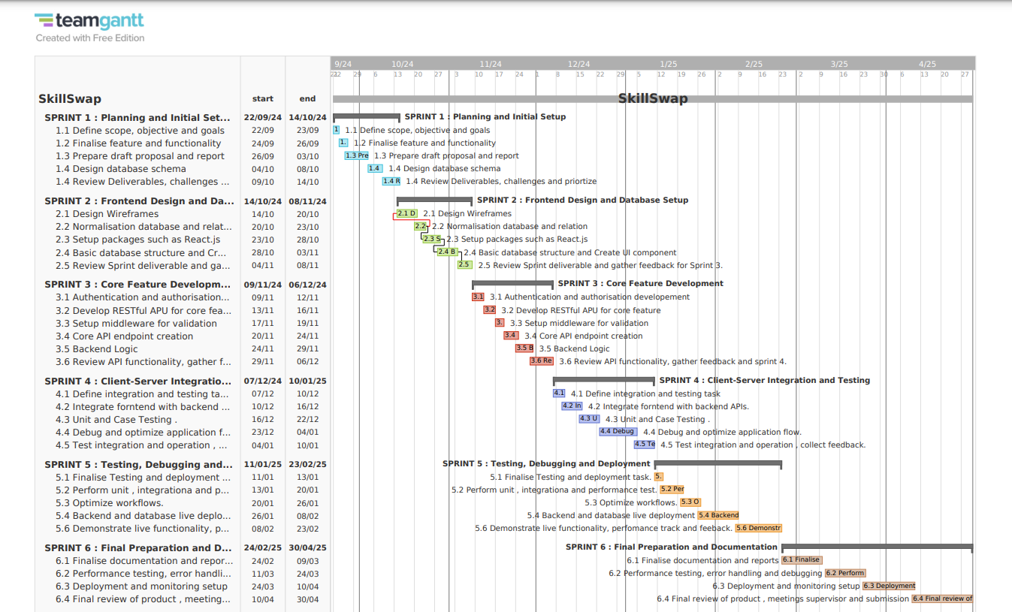

Figure 8 : Project Gantt Chart : SkillSwap

# Conclusion

This platform overall aims to bring a place for skill-sharing where users can learn, teach, and gain knowledge through a virtual reward system. Directly or indirectly, it will help fosters a vibrant community with collaboration and accessibility, which will eliminate financial barriers and seek to bridge the gap between learners and educators. This project will bring modern technology and development procedure together to deliver a reliable, scalable and robust system. Therefore, this proposal lays the foundation for building scalable and user-friendly system meeting each person’s personal and professional growth.

# Bibliography

Admin, m., 2023. *MtractionEnterprise.* [Online]   
Available at: https://www.mtractionenterprise.com/blog/why-contingency-planning-is-important-in-software-development/

CEIC, 2023. *Nepal GFP per Capita.* [Online]   
Available at: https://www.ceicdata.com/en/indicator/nepal/gdp-per-capita

Dr. (CA) Megha Sharma, M. A. V. D. A. S., 2023. *Impact of E-Education on Employment Oppurtunity.* [Online]   
Available at: https://www.researchgate.net/publication/371875639_A_Study_on_the_impact_of_E-Education_on_Employment_Opportunities

Ed-admin, 2023. *The rise of Online Learning Platforms and thier benefits for students..* [Online]   
Available at: https://www.linkedin.com/pulse/rise-online-learning-platforms-benefits-students-ed-admin/

Gurnov, A., 2024. *Agile Methodology in Project Management.* [Online]   
Available at: https://www.wrike.com/project-management-guide/faq/what-is-agile-methodology-in-project-management/

Kharrati, K., 2022. *Global E-Learning Market Share,* Sandy, USA: Custom Market Insights , Global Market INC.

Malsam, W., 2023. *Scrum Methodology.* [Online]   
Available at: https://www.projectmanager.com/blog/scrum-methodology

Singg, S., 2024. *Online Education Growth.* [Online]   
Available at: https://www.linkedin.com/pulse/future-online-learning-trends-innovations-sandeep-singh-zsfjf/

Statista, 2023. *Online Learning Platforms - Worldwide.* [Online]   
Available at: https://statista.com/outlook/emo/online-education/online-learning-platforms/worldwide

WIR, 2022. *Wealth and Income of the world.* [Online]   
Available at: https://wir2022.wid.world/chapter-1/

# APPENDIX

## APPENDIX 1.1

Scrum is a widely known project management framework that promote collaboration, accountability through an iterative progress for complex projects. Since SkillSwap is a complex system with various modules and features, scrum framework allows for better management of the complexity, members and timely deliverables by breaking down it into smaller section known as sprints . (Malsam, 2023)

The implementation of scrum in Skillswap will be achieved by defining core objectives and creating backlogs for features like user authentication and SkillCoin system. Tasks will be divided into sprints for each specific features along with sprint meetings, retrospection, review and feedback, all for ensuring alignment with the goals. This will help optimize the process for continuous improvement.

Therefore, this approach will benefit Project Skillswap, in several ways. Not only will it ensure timely delivery of the systems feature, but things such as regular review, optimization will keep supervisor, stakeholders aligned with the project’s progress. Continuous testing and cycles will help generate a high-quality SkillSwap platform with maximum satisfaction for the clients.

## APPENDIX 1.2

The Agile Methodology is a project management process that involves constant collaboration and workings in iterations, which divides works into stages known as sprints. Therefore, due to its benefits such as rapid progress, team collaboration, objective alignment and continuous improvement it is a suitable SDLC lifecycle for this project . (Gurnov, 2024)

## APPENDIX 1.3

1. **Fully Functional Platform :** 
   * A user-friendly and responsive MERN- stack application deployed in the web, which is equipped with RESTful APIs for facilitating user’s request and application functionality.
   * Fully framed robust backend infrastructure based on Node.js framework Express.js. for developing endpoints for various requests, integrated along with JWT and stateless authentication for user tracking.
   * Optimized and well-structured database using MongoDB database with proper usage case schema and entity division.
2. **Documentations :**
   * Technical Documentation entailing details of topics such as system architecture, database schema, API specifications, development process, description of components, instructions and reference guides.
   * A manual that will guide users to navigate and utilize the platform effectively.
3. **A Final Deployment application** with a well-defined documentation including deployment scripts, technical resources, and a guide for future scalability and maintenance.

## APPENDIX 1.4

In detail feature supported by SkillSwap along with their benefits:

1. **Robust and Engaging Skill Coin System** **–** This feature will allow users to earn coins for multiple platform activities which will use to unlock content or post new lessons later. A self-sustaining mechanism is created for both creators and learners ensuring accessibility without financial barriers. Coins can be purchased whenever required.
2. **b. Content Creation Opportunity and Rewards –** Creators can enjoy various features such as publishing video lessons, tutorials and resources on different skillsets, at the same time earn reward for contributing to the repository.
3. **c. System for Community Collaboration and Flexible Learning -** . The system will provide interactive activities such as exchanging feedback, reviews, course detailing. Additionally, the application will ensure offline accessibility and provide course recommendations.
4. **Diverse Learning Areas -**  The platform will cover various fields such as writing, photography, production and even freelancing lessons to cater wide range of interests and skills .